**A Project Report**

*On*

**“Hotel & Restaurant Management”**

*Submitted By*

**Sonani Jemish (206230307012)**

**Vaghasiya Dhrudeep (206230307008)**

**Gadhiya Yash (206230307007)**

**Shah Manthan (206230307019)**

*In partial fulfilment of requirements for the degree*

*Of*

**DIPLOMA ENGINEERING**

*In*

*Computer Engineering*



**Government Polytechnic, Gandhinagar**

**Gujarat Technological University, Ahmedabad**

December - 2022

**CERTIFICATE**



**Government Polytechnic, Gandhinagar**

Computer Engineering

2022-2023

This is to certify that the project work embodied in this report entitled **Hotel & Restaurant Management** was carried out by **Mr. Sonani Jemish (206230307012), Mr. Vaghasiya Dhrudeep (206230307008), Mr. Gadhiya Yash(206230307007) & Mr. Shah Manthan (206230307019) at Government Polytechnic, Gandhinagar** for partial fulfillment of Diploma degree to be awarded by Gujarat Technological University (GTU). This project work has been carried out under my supervision and is to the satisfaction of department.

**Place:** GP, Gandhinagar

**Date:**

**Internal Guide Head of the Department**

Prof. Meeta Prajapati Prof. Manish J Desai

**Acknowledgement**

I sincerely feel the credit of the project work could not be narrowed down to only on individual. The development of this project involves many valuable contributions. Getting the opportunity for this project of “**Hotel & Restaurant**” as fulfillment of diploma (computer engineering) has been brightening experience for the near future to come and a focus on excellence in this venture, we are constantly guided and encouraged by **Prof. Meeta Prajapati** who is our internal guide.

I would also thank our Head of the Department **Prof. Manish J Desai** for giving us such a wonderful chance to work with this interesting project and perform the project work for the entire duration of the semester and also thanks to internal guide for project technical guidance and giving inspiration in all the way during project making. Finally, I would like to thank our parents, friends and almighty for being with us to support directly or indirectly while making this project.

**Abstract**

Hotel & Restaurant Management is Web-Development based application that allows the Hotel & Restaurant to handle all activities online. Interactive GUI and the ability to manage various Hotel & Restaurant booking make this system very flexible and convenient. We have tried our best to make the complicated process of Hotel & Restaurant Management System as simple as possible using user friendly GUI and menu-oriented interface and simple database programming. Our project is designed like that users do not have to try like other web applications. The system provides information regarding the different Hotels that are available and their status specific to availability. The project is made in such a way that the user does not have to consume more time on hotel room booking and restaurant table booking, it means all progress is computerized.

Hotel & Restaurant management project also provide staff management and other necessary services. Customers can check available rooms & restaurant tables and book online. Admin has the power to either approve or disapprove the customer’s booking request. The users can use the system to advertise available rooms.

The complete project is developed using the front-end language HTML, CSS, and JavaScript. And for the back-end language we use NodeJS and for the database we use MySQL services.

**Table of Contents**

Acknowledgement

Abstract

|  |  |  |
| --- | --- | --- |
| Chapter 1 | Introduction…………………………………………….…….. | 1 |
|  | 1.1 Problem Summary……………………………….…………   * 1. Project Purpose………………………………….…………   2. Project Scope…………………………………….…………   1.4 Project Objective………………………………...…………. | 1  1  2  2 |
| Chapter 2 | System specification……………………………………………. | 3 |
|  | * 1. Hardware Requirement…………………….……………….   2. Software Requirement……………………...……………….   3. Requirements Analysis…………………….……………….   4. Constraints………………………………….………………   5. Assumptions and Dependencies…………….………………   6. Technology and Literature Review………….……………… | 3  4  4  7  8  8 |
| Chapter 3 | System diagrams………………………………………………. | 10 |
|  | * 1. Data Dictionary………….………………….………………   2. ER Diagram…………….….…………………….………….   3. Data Flow Diagram…………………………………………   4. Use case Diagram……………………….………………….   5. Sequence Diagram.………….………………………………   6. Activity Diagram…………………………………………… | 10  12  13  15  16  17 |
| Chapter 4 | Implementation………………………………………………… | 19 |
| Chapter 5 | Conclusion…..…………………………………………………. | 21 |
| Chapter 6 | Bibliography & Reference……………………………………... | 22 |

**Chapter 1: Introduction**

* 1. **Problem Summary**
* Hotel & Restaurant Management System is the website that provides customers to reserve rooms and tables and check whether the rooms and tables are vacant or not.
* After choosing the room or table in the hotel or restaurant all booking and reservation process is done on the site. Confirmation details will be sent by SMS or Gmail.
* When customers select how many rooms they want for how many days they can see the total amount on the website at a time.
  1. **Project Purpose**
* The purpose of the hotel & restaurant booking system is to automate the existing manual system with the help of computerized equipment so that their valuable information can be stored for a longer period with easy accessing and manipulation of the same.
* This System is beneficial to all business people because if they do not have sufficient time to book that time they can use an online Hotel & Restaurant.
* Hotel and restaurant management web application allows people to book rooms in hotels and book tables in restaurants easily from one place.
  1. **Project Scope**
* The scope of our project is that the customer who is facing problems in hotel booking will be solved. By the help of our website costumer can book any hotel at any place.
* Searching of Hotels & Restaurant Will be Easier. We will provide hotel & restaurant details and contact number.
* We will provide hotels Details & food reviews etc.
* We will provide feedback section in that user can give feedback about that hotels & Restaurant.
  1. **Project Objective**
* We will provide all types of hotels and restaurant on our website, like we will try to provide different section of hotels like (5Star, 3Star, Normal, Budget Friendly) etc.
* Our website will display that currently how many rooms are available in hotel & how many tables are available in restaurant.
* We will give checkout option where you can conform your booking of hotel.

**Chapter 2: System specification**

* 1. **Hardware Requirement**

For any website to run on a device, it should have compatible specification to achieve at least minimum requirement of the website.

There are following hardware requirement which must be fulfilled to run Hotel and Restaurant Management Website: -

**Client-side Requirement:**

1. RAM - 2 GB
2. Hard Disk Space – 1 GB free
3. Processor: Intel Platinum Quad core or more
4. Internet: Required
5. Screen-resolution: 1280×1024

**Server-side Requirement:**

1. RAM: 4 GB
2. Processor: Intel Platinum Quad core or more
3. Hard Disk Space – 100 GB SSD to faster access
4. Internet: Required

* 1. **Software Requirement**

There are following software requirement which must be fulfilled to run Hotel and Restaurant Management Website: -

1. OS: windows 7 or more
2. Frontend: HTML, CSS, JAVA Script
3. Backend: MySQL, PHP
4. Programming Tools: VS Code
5. Documentation Tools: Microsoft Word, Microsoft PowerPoint
   1. **Requirements Analysis**

Requirement analysis for web applications encompasses three major tasks: formulation, requirements gathering and analysis modeling. During formulation, the basic motivation and goals for the web application are identified, and the categories of users are defined. In the requirements gathering phase, the content and functional requirements are listed and interaction scenarios written from end-user’s point-of-view are developed. This intent is to establish a basic understanding of why the web application is built, who will use it, and what problems it will solve for its users.

**Functional Requirements:**

**Module Description:**

***Admin Module:***

The Functionalities of the Administrator is: The administrator should login into the system with unique his/her password and username. If the username and password is validated then he can gain access to the system. View the hotels can update and delete the hotels. Post the special offers, add new hotel to the hotels list. Insert /View the Availability and Price. Post the links. Adding the links to the hotels and as well view the links. Blocks the user view the status of the users. Restrict the user to the see the more information without login.

***The Administrator can do the following actions:***

Admin

* Login.
  + Input: username, Password.
  + Output: Login successful.
* Edit Content.
  + Input: Add or Remove Hotels and Restaurants.
  + Output: Edit successful.
* Manage Offers.
  + Input: Add / Remove Offers and Coupon.
  + Output: According Offers / Coupon price will change.
* Confirmation Booking.
  + Input: Accept / Decline Booking.
  + Output: Booking Accept / Decline.
* Check Feedback.
  + Input: Check Feedback.
    - * Output: According to feedback improve Website / Hotels & Restaurant Services.

***User Module:***

The Functionalities of the User is: A new User can register with the application by entering his appropriate details. The User should login into the system with unique his/her password and username. If the username and password is validated then he can gain access to the system. The User can change his password, To change the password, it should ask for the old password, new password and confirm new password

***The User can do the following actions:***

User

* Registration.
  + Input: Full Name, Email id, Phone no, username, password
  + Output: Registration successful
* Login.
  + Input: username, Password
  + Output: Login successful
* Book Rooms and Hotel.
  + - * Input: Check room available or not, check best hotels and restaurants
  + Output: Booking Cart
* Check in and check out time.
  + - * Input: How many people stay, how many days to stay, total no of room, check in and checkout time, extra bed
  + Output: Booking Successful
* Payment.
  + Input: UPI id, Bank details, Card details
  + Output: Payment Successful
* Feedback.
  + Input: Your experience
  + Output: Thank you for good feedback, please visit again.

**Non-Functional Requirements:**

* Security.
* Speed of web service.
* Forgot Password.
  1. **Constraints**
* Proper Details and information about hotels & restaurant.
* Keeping up with latest technology.
* Maintenance of website.
* Customer Care & Customer Services.
* Fear of Online booking.
  1. **Assumptions and Dependencies:**

**Assumption:**

* The User must have basic knowledge of using a web-browser.
* The servers and database will work properly.
* User Will book Hotel & Restaurant responsibly.

**Dependencies:**

* We have embedded map, so user can get the location of the hotel or restaurant properly.
* Online payment method is available on hotels & restaurant.
* Our fonts are being used from google.
  1. **Technology and Literature Review**

**HTML:**

* HTML stands for Hypertext Markup Language.
* It is used to design web pages using a markup language. HTML is the combination of Hypertext and Markup language.
* A markup language is used to define the text document within tag which defines the structure of web pages.

**CSS:**

* CSS (Cascading Style Sheets) is the language for describing the presentation of Web pages, including colors, layout, and fonts.
* It allows one to adapt the presentation to different types of devices, such as large screens, small screens, or printers.

**Java Script:**

* Our JavaScript Tutorial is designed for beginners and professionals both. JavaScript is used to create client-side dynamic pages.
* JavaScript is an object-based scripting language which is lightweight and cross-platform.

**MySQL:**

* SQL stands for Structured Query Language.
* SQL lets you access and manipulate databases.

**PHP:**

* PHP is an acronym for "PHP: Hypertext Preprocessor"
* PHP is a widely-used, open source scripting language
* PHP scripts are executed on the server
* PHP is free to download and use

**WHY PHP ?**

* PHP runs on various platforms (Windows, Linux, Unix, Mac OS X, etc.)
* PHP is compatible with almost all servers used today (Apache, IIS, etc.)
* PHP supports a wide range of databases
* PHP is free. Download it from the official PHP resource: [www.php.net](http://www.php.net/)
* PHP is easy to learn and runs efficiently on the server side

**Chapter 3: System diagrams**

* 1. **Data Dictionary**

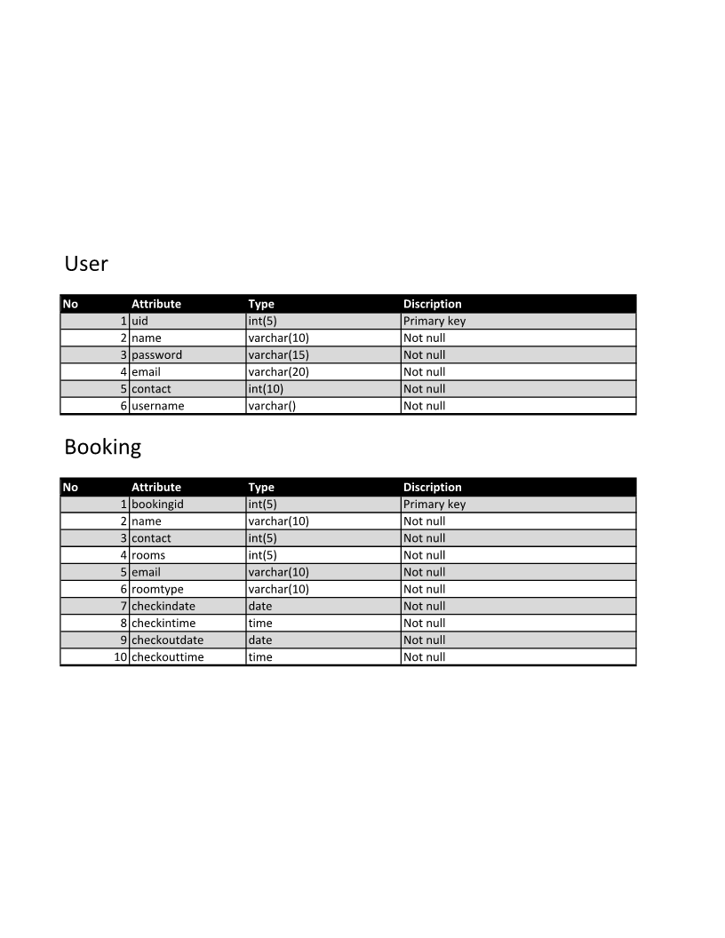

* 1. **ER Diagram**

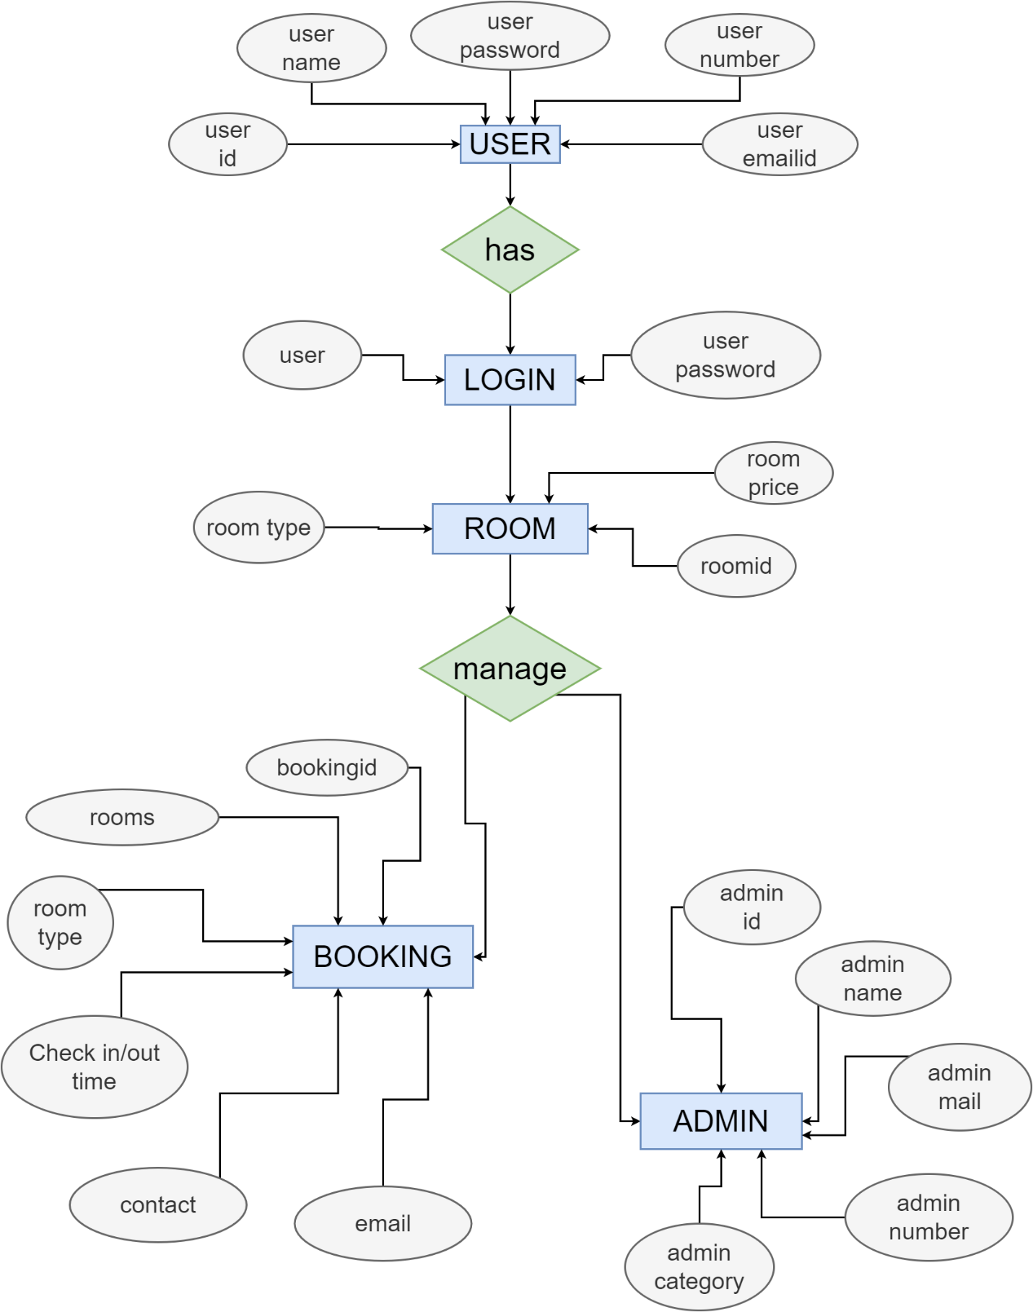

name

* 1. **Data Flow Diagram Level-0**

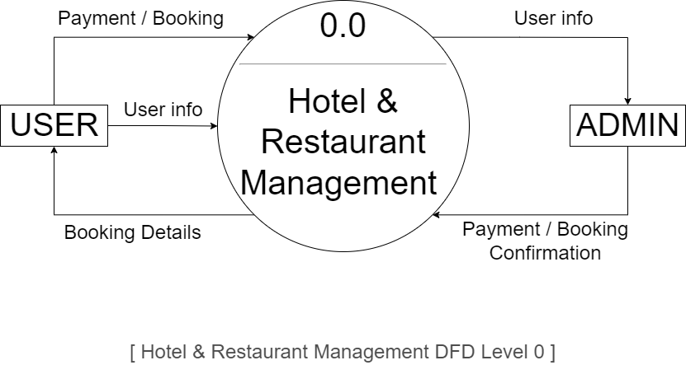

**3.3.1 Data Flow Diagram Level-1**

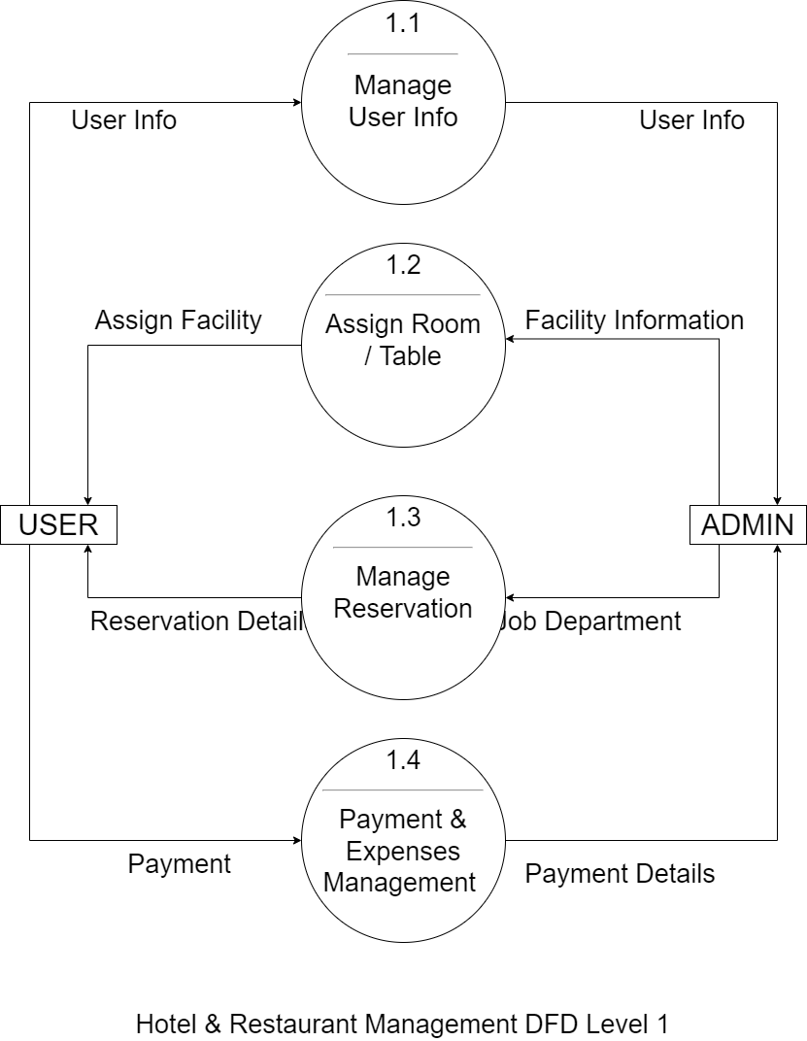

**3.3.1 Data Flow Diagram Level-1**

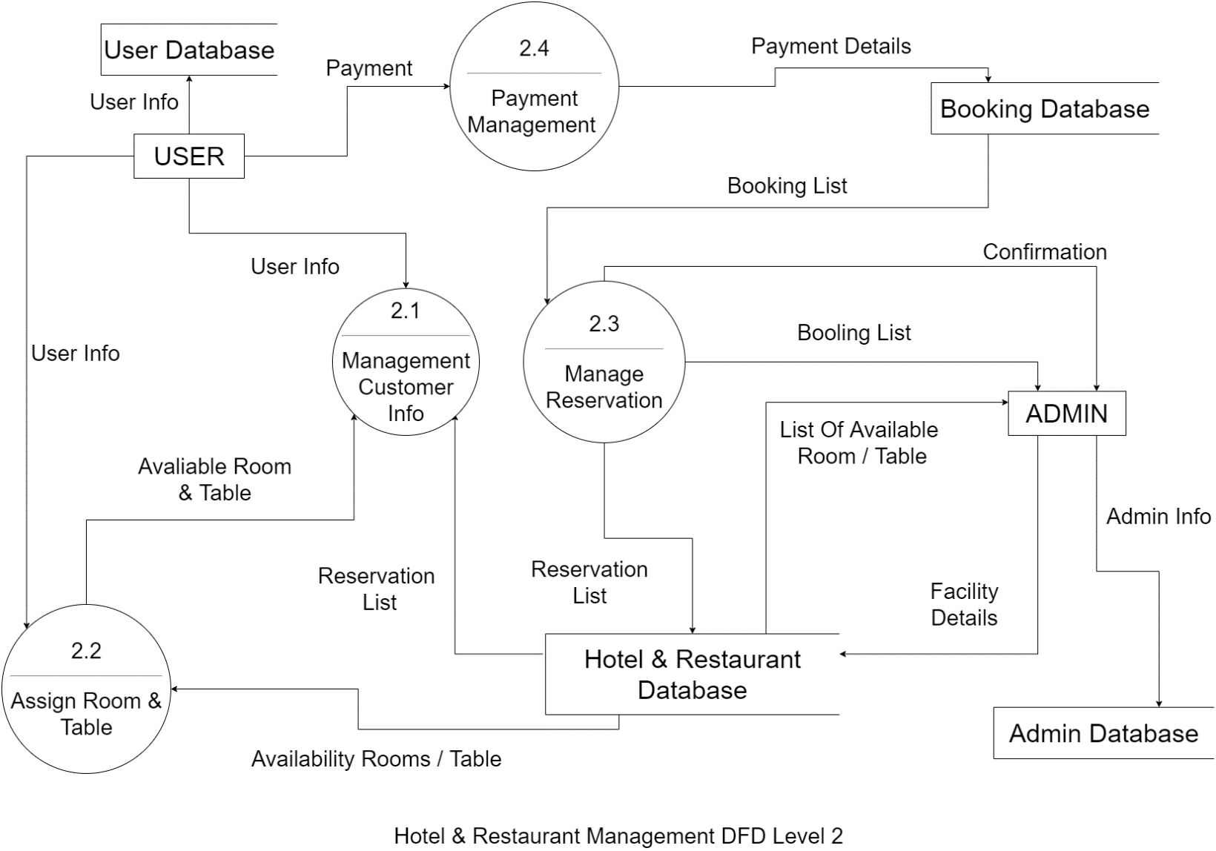

* 1. **Use case Diagram**

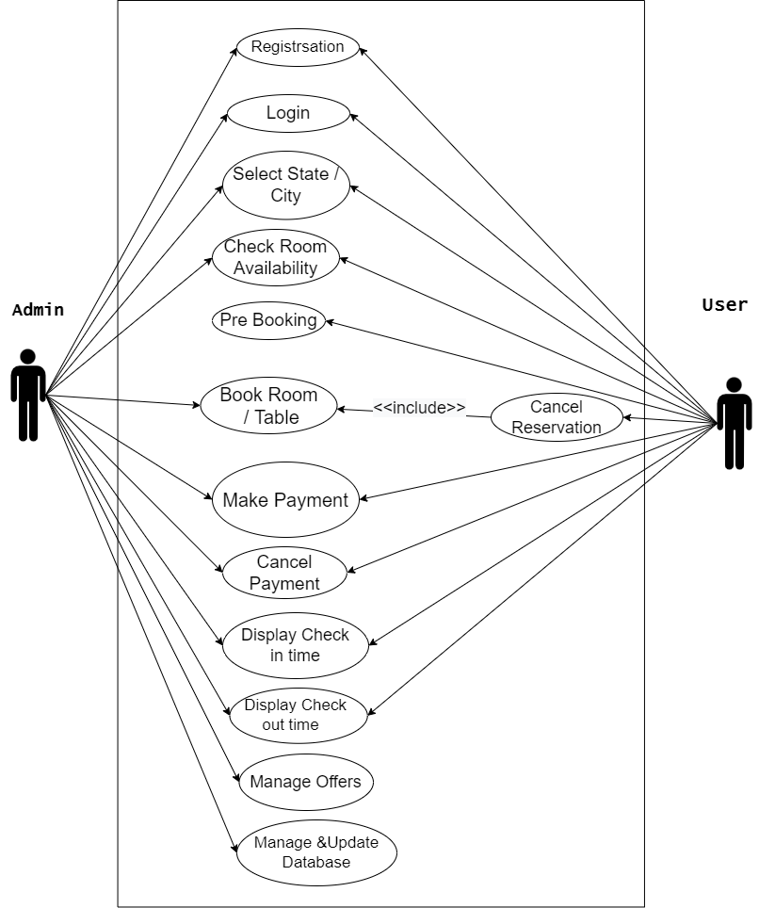

* 1. **Sequence Diagram**

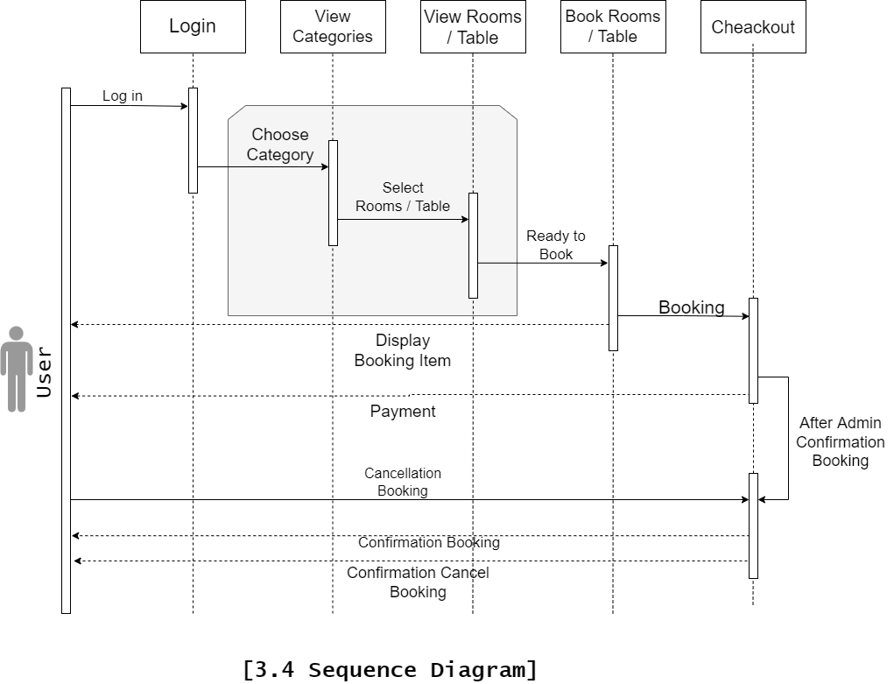

* 1. 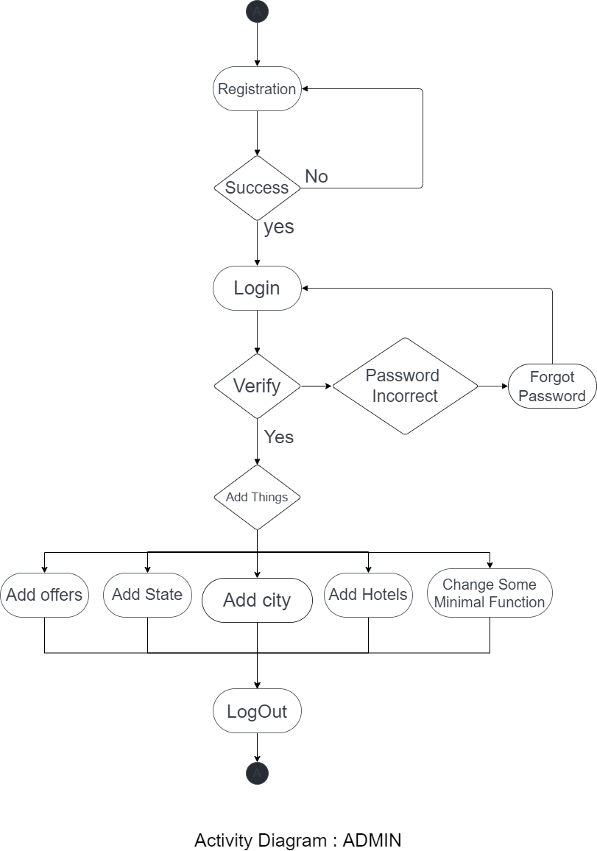**Activity-diagram**

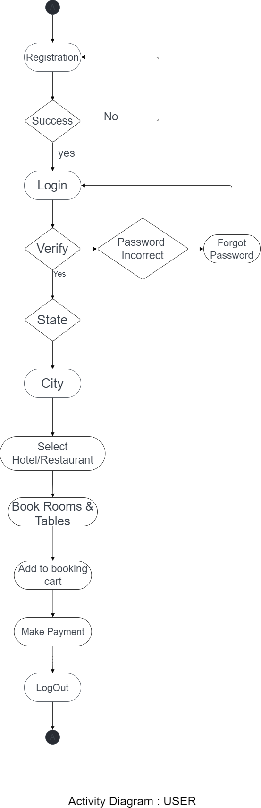

**Chapter 4: Implementation**

* 1. **Implementation**

This project is designed to meet the requirements of Online Hotel & Restaurant Management. It has been developed in NodeJS & MySQL keeping in mind the specifications of the system.

* We will optimize the web-site more and more as time passes so its performance is best.
* Security updates will be given for some time.
* Optimize the code of web application will be increase for increase the performance.
* We will optimize images, videos, icons, etc. for more performance

**4.2 Snapshot**

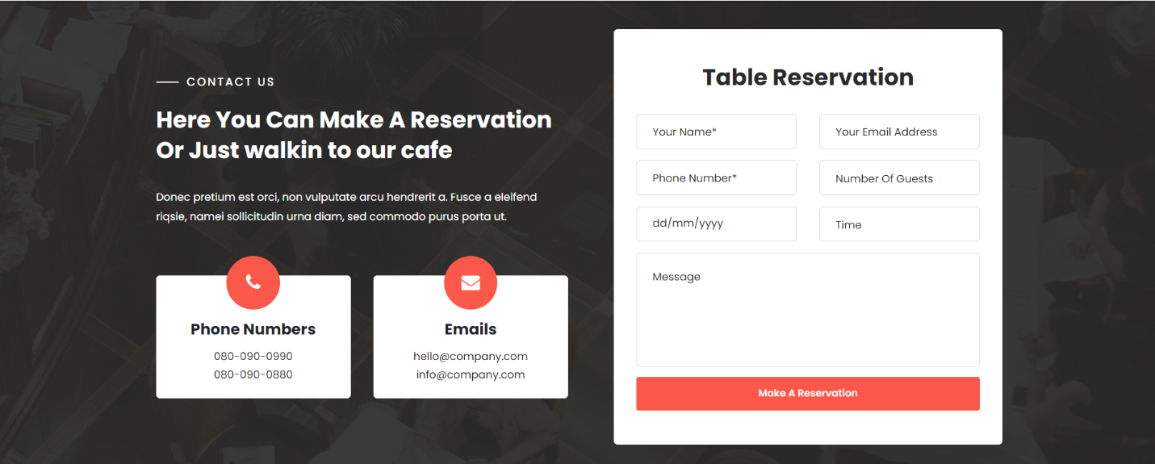

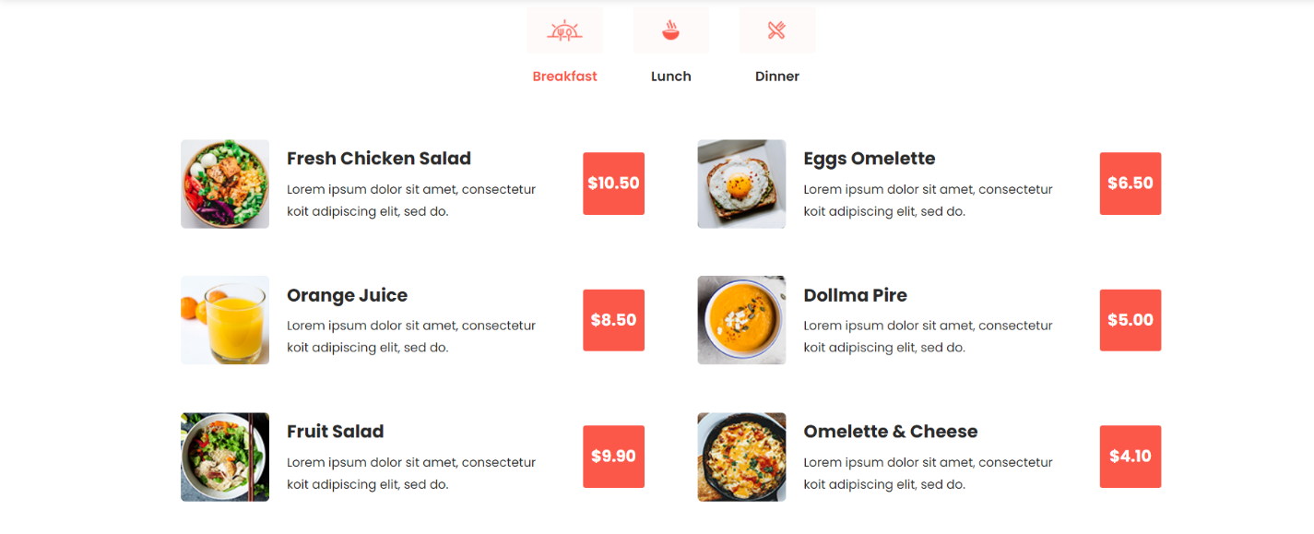

**Chapter 5: Conclusion**

**HOTEL & RESTAURANT MANAGENMENT SYSTEM** is a Web-portal Development Company specializing in providing custom solutions for small businesses. We strive to build solutions to your specific needs to get the job done right the first time. We pay special attention to the ease of use and utilize the

latest in technology.

This system is developed for the exclusively for the people . It provides

facilities to the user with user friendly modules with sub modules. This

system is developed in understandable approach which can be easier to

the layman of the computers. This system is developed totally GUI based

and with smart links.

**Chapter 6: Bibliography & Reference**

* 1. **Books**
* [Node.JS Web Development](https://www.amazon.com/Node-JS-Web-Development-David-Herron/dp/1785881507/ref=pd_cp_14_3?_encoding=UTF8&pd_rd_i=1785881507&pd_rd_r=0Z90PCJJG3XJ52Q45S02&pd_rd_w=mm59A&pd_rd_wg=L8cth&psc=1&refRID=0Z90PCJJG3XJ52Q45S02) : [David Herron](https://twitter.com/7genblogger)
* [Murach’s MySQL 3rd Edition](https://amzn.to/2nrPdUU) : Murach
  1. **Websites**
* [https://www.w3schools.com/tags/default.asp (HTML)](https://www.w3schools.com/cssref/default.asp)
* <https://www.w3schools.com/cssref/default.asp> (CSS)
* <https://www.w3schools.com/jsref/default.asp> (JS)
* <https://www.w3schools.com/sql/sql_ref_keywords.asp> (SQL)
* Draw.io (Making Diagrams and Flowchart)